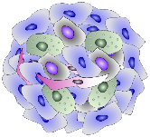
COST ACTION 17104

Annual training school – 2020

3D cell models – a powerful tool to study MDR
StrataCell

Training School StrataCell 2020 Application FORM

To apply for the training school StrataCell 5th-6th November 2020, please complete the details below:

First Name:
Family Name:
Email:
Institution:
Country:
Title of PhD if applicable:
PhD/MSc Topic (max. 500 words):
How this Training school can contribute to your future career?
Are you or members from your lab participating in COST Action CA17104?

